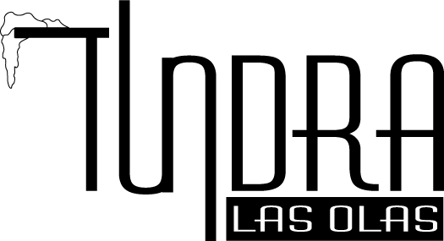

PORT
Warres Port Tawny 10 $15.00
Dows Port Tawny Boardroom $12.00
Taylor Tawny 10 $14.00
Grappa $8.00
Fernet-Branca $10.00

CORDIALS
Amaretto Disarrono $12.00
Bailey’s Irish Cream $10.00
Benedictine $12.00
Campari $10.00
Chambord $12.00
Cointreau $10.00
Drambuie $12.00
Frangelico $12.00
Galliano $10.00
Godiva Capp $12.00
Godiva Dark Chocolate $12.00
Godiva White $12.00
Grand Marnier $14.00
Kahlua $10.00
Limoincello, Villa Massa $12.00
Sambuca Romana $10.00
Sambuca Romana Black $10.00
Tia Maria $10.00

COGNAC
Courvoisier VSOP $13.00
Courvoisier XO $18.00
Hennesy VSOP $15.00
Martell Cordon Bleu $16.00
Remy Martin XO $20.00
Louis XIII $150.00

DESSERTS

WHISKEY BREAD PUDDING
Walnuts, Currants, Vanilla Bean Cream 7

FRIED STRAWBERRIES
White Chocolate Anglaise 8

CRÈME BRULEE
Fresh Berries 8

WARM CHEESECAKE BROWNIES
Vanilla Bean Ice Cream 8

TUNDRA DESSERT TOUR
Sampling of 4 of our Popular Dessert 12

LIQUID DESSERT
Godiva Chocolate Liquor, Kahlua, Coconut Rum Vanilla Ice Cream 12

Espresso 5
Café Latte 5
Cappuccino 5
American Coffee Reg or Decaf $3.50 Fine Tea Selections 5

