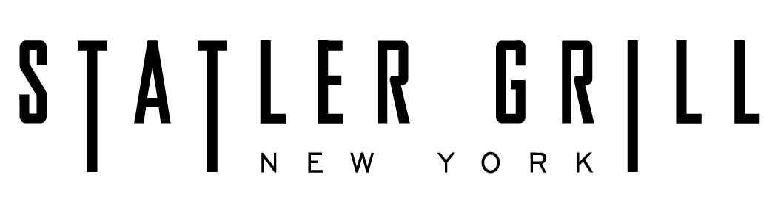

groupon prix fixe

appetizers
tomato & buffalo mozzarella
beefsteak tomatoes & buffalo mozzarella with sundried tomatoes, pesto, olive oil & balsamic vinegar
classic caesar salad
fried calamari
french onion soup

entrees
new york prime aged porterhouse steak for two
new york prime sirloin
north atlantic grilled salmon
chilean sea bass
pasta of the day

chef’s selection of two side dishes

homemade a desserts
new york style cheesecake
bread pudding with bourbon souce

choice of coffee or tea

groupon wine features
al verdi pinot grigio
douglass hill chardonny
martinez corta tempranillo
mont pellier pinot noir

